Install TAPI Driver
Follow the instructions below to install the TAPI driver
- Copy the 2 TAPI binary files, OnSIP.TSP and OnSIPUI.dll, to the c:\windows\system32 directory.

Note: If you are already have the OnSIP TAPI driver installed and are updating with a new version, then the current version must first be uninstalled. See Step 2 below, first uninstall by clicking on OnSIP TAPI Driver and click on the Remove button. The new files can then be copied to the c:\windows\system32 directory.

- Open the Windows Control Panel (e.g. Start / Settings / Control Panel ). Double click on the Phone and Modem Options icon. Click on the Advanced tab, the following will be displayed…
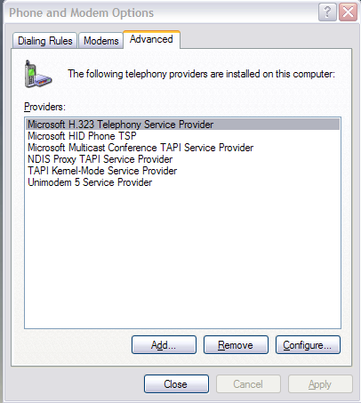
- Click on the Add button, the following will be displayed…
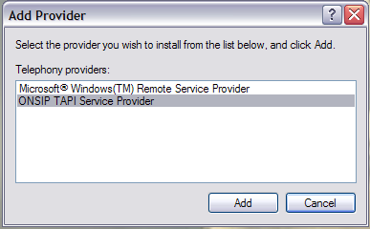
- Select the OnSIP TAPI Service Provider item and click on the Add button. The Configuration dialog for the OnSIP TAPI driver should be displayed. Enter in the OnSIP phone number and logon information.
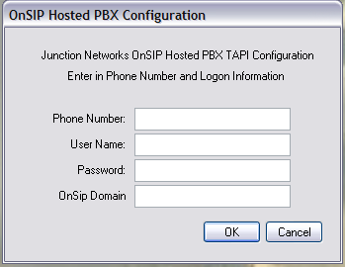

Phone Number: OnSIP Phone Number – this may be used for display purposes by TAPI applications.

User Name: OnSIP logon user name. Only specify the name, do not specify the domain name in this field. e.g. bjones

Password: OnSIP logon password

OnSip Domain: The domain assigned for the OnSIP Hosted PBX, e.g. yourcompany.onsip.com

Click on OK to complete the Installation. The TAPI Driver is now installed.

Note: Future versions of the TAPI driver will have an option to test the settings from this dialog.

Outlook Integration
Outlook provides integration with TAPI drivers to dial contact numbers.
- In the Contacts view, either right click on an entry and select Call Contact, or while within a Contact Item, click on the Call button in the view. The following dialog should be displayed…
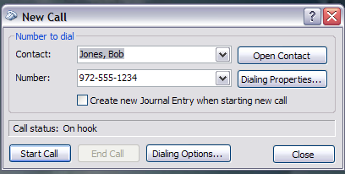
- To ensure that the OnSIP TAPI driver is used, click on the Dialing Options button. The following dialog will be displayed. In the Connect using line option at the bottom, select the TAPI driver option that matches the phone number entered in the TAPI Configuration dialog. Click on OK to save the changes.
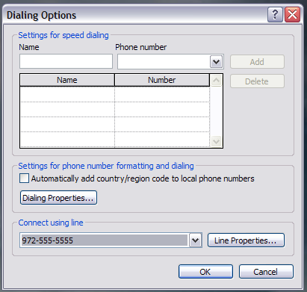

- Back in the New Call dialog, modify the phone number if necessary, then click on the Start Call button. This will result in a request for the OnSIP PBX to make the call. The OnSIP phone will ring, this is required to initiate the call. Answer the phone to start the calling process. One the phone is answered, then the call to the requested phone number will be made.

Note: The New Call dialog has an option to End Call. Currently this option is not supported, it will be supported in a future release.

